Suited lawyers rally against Greek pension reform

[](http://www.ap.org/)

By **DEREK GATOPOULOS**19 hours ago

* [](https://www.tumblr.com/share/photo?clickthru=http%3A%2F%2Ffinance.yahoo.com%2Fnews%2Fsuited-lawyers-rally-against-greek-160037363.html%3Fsoc_src%3Dmediacontentstory%26soc_trk%3Dtu&caption=ATHENS%2C%20Greece%20%28AP%29%20%E2%80%94%20Several%20thousand%20lawyers%2C%20many%20wearing%20ties%20or%20high%20heels%2C%20marched%20to%20parliament%20Thursday%20to%20protest%20a%20planned%20overhaul%20of%20the%20pension%20system%20by%20the%20country%26%2339%3Bs%20leftwing%20government.&source=http%3A%2F%2Fl2.yimg.com%2Fbt%2Fapi%2Fres%2F1.2%2F.S8gPEe4EOq5gxVcy8GpJw--%2FYXBwaWQ9eW5ld3NfbGVnbztpbD1wbGFuZTtxPTc1O3c9NjAw%2Fhttp%3A%2F%2Fmedia.zenfs.com%2Fen_us%2FNews%2Fap_webfeeds%2F7ad10f458bbb85028d0f6a7067003ecf.jpg)
* [](https://www.facebook.com/dialog/feed?app_id=90376669494&redirect_uri=http%3A%2F%2Ffinance.yahoo.com%2F_xhr%2Fmediacontentsharebuttons%2Fpostshare%2F%3Fsrc%3Dfb&link=http%3A%2F%2Ffinance.yahoo.com%2Fnews%2Fsuited-lawyers-rally-against-greek-160037363.html%3Fsoc_src%3Dmediacontentstory%26soc_trk%3Dfb&picture=http%3A%2F%2Fl2.yimg.com%2Fbt%2Fapi%2Fres%2F1.2%2F.S8gPEe4EOq5gxVcy8GpJw--%2FYXBwaWQ9eW5ld3NfbGVnbztpbD1wbGFuZTtxPTc1O3c9NjAw%2Fhttp%3A%2F%2Fmedia.zenfs.com%2Fen_us%2FNews%2Fap_webfeeds%2F7ad10f458bbb85028d0f6a7067003ecf.jpg&name=Suited+lawyers+rally+against+Greek+pension+reform&description=ATHENS%2C+Greece+%28AP%29+%E2%80%94+Several+thousand+lawyers%2C+many+wearing+ties+or+high+heels%2C+marched+to+parliament+Thursday+to+protest+a+planned+overhaul+of+the+pension+system+by+the+country%26%2339%3Bs+leftwing+government.&display=popup&show_error=yes)
* [](https://twitter.com/share?text=Suited+lawyers+rally+against+Greek+pension+reform&url=http%3A%2F%2Ffinance.yahoo.com%2Fnews%2Fsuited-lawyers-rally-against-greek-160037363.html%3Fsoc_src%3Dmediacontentstory%26soc_trk%3Dtw&via=YahooFinance)
* [](http://finance.yahoo.com/_xhr/mtf_popup/?url=http%3A%2F%2Ffinance.yahoo.com%2Fnews%2Fsuited-lawyers-rally-against-greek-160037363.html%3Fsoc_src%3Dmediacontentstory%26soc_trk%3Dma&site=finance&region=US&lang=en-US&content_id=9ec9296a-0c3d-3473-94a0-90f81b9f69dd&alias_id=story%3Dsuited-lawyers-rally-against-greek-160037363)

[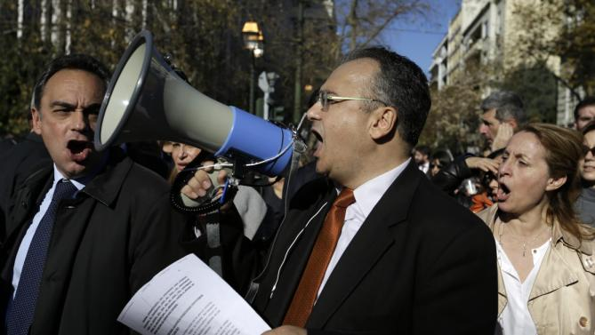](http://finance.yahoo.com/news/suited-lawyers-rally-against-greek-160037363.html)

.

View gallery

* [](http://finance.yahoo.com/news/suited-lawyers-rally-against-greek-160037363.html)

.

* [](http://finance.yahoo.com/news/suited-lawyers-rally-against-greek-160037363.html)

.

* [](http://finance.yahoo.com/news/suited-lawyers-rally-against-greek-160037363.html)

.

* [](http://finance.yahoo.com/news/suited-lawyers-rally-against-greek-160037363.html)

.

ATHENS, Greece (AP) — Several thousand lawyers, many wearing ties or high heels, marched to parliament Thursday to protest a planned overhaul of the pension system by the country's leftwing government.

Chanting "No retreat till we're vindicated," the lawyers came from associations around Greece that are calling on the government to scrap key provisions outlined in government proposals this month.

Pension reform in rapidly-aging Greece is a key demand being made by bailout lenders, who are studying the proposals and have argued that current levels of state funding for the retirement system are unsustainable.

In Brussels, Greek Finance Minister Euclid Tsakalotos attended a meeting of eurozone finance ministers but said the proposed Greek reforms were unlikely to be discussed.

The pension reforms have drawn broad opposition from various professional groups, with farmers planning protests to start on Jan. 20, with possible highway blockades, starting in northern Greece.

The country's largest labor union, the GSEE, also called an emergency meeting for Friday to consider strikes.

"There's a financial crisis that has hit incomes. Add to that the high taxes and now the higher income contributions for pensions, and many businesses in our profession and other professions will not be able to survive," said Athens lawyer Panagiotos Vrettos, holding a protest banner with several other protesters outside parliament.

"I am 65 years old and I could retire, but my pension would be small and I'd like to keep my office going. I have seven associates who've worked with me for years. But now I don't if it can keep going with these changes," he said.

Opposition to the long-anticipated pension reforms has added pressure on the government, which won two general elections last year but has a slim majority in parliament.

An opinion poll for a Sunday newspaper late last month showed a sharp decline in support for the governing Syriza party, with a projected 40.5 percent of voters refusing to back any political party.