Greece pushes for more health, education staff to cushion blow of cuts

**ATHENS** | BY RENEE MALTEZOU AND LEFTERIS PAPADIMas

[[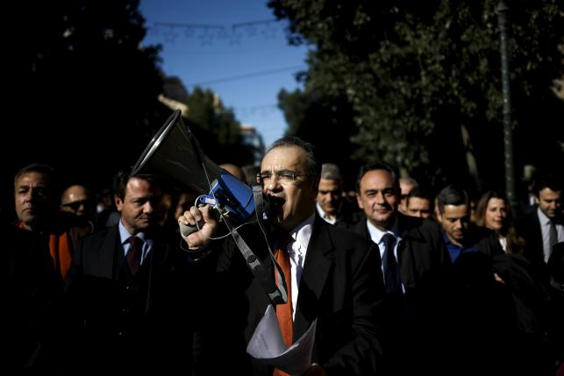](http://www.reuters.com/news/picture/greece-pushes-for-more-health-education?articleId=USKCN0US1MU20160114&slideId=1109508974)](http://www.reuters.com/news/picture/greece-pushes-for-more-health-education?articleId=USKCN0US1MU20160114&slideId=1109508974" \t "_top)

[[](http://www.reuters.com/news/picture/greece-pushes-for-more-health-education?articleId=USKCN0US1MU20160114&slideId=1109508975)](http://www.reuters.com/news/picture/greece-pushes-for-more-health-education?articleId=USKCN0US1MU20160114&slideId=1109508975" \t "_top)

Greek lawyers take part in a demonstration against government pension reforms affecting their sector in Athens, Greece, January 14, 2016.

REUTERS/ALKIS KONSTANTINIDIS

Greece said on Thursday it wanted to persuade its creditors to let it hire more health staff and teachers in the early stages of its overhaul of the public sector, part of a wider attempt to cushion the blow of harsh austerity.

Athens has promised to cut public sector spending and increase efficiency under the terms of its international bailout, and Prime Minister Alexis Tsipras said he was committed to the plan.

But the government, which has a thin parliamentary majority, has also promised to help the most vulnerable by improving health and education - services that have been particularly hard hit during the country's debt crisis.

"Our aim is to convince (the lenders), and our arguments are very strong and serious, to bring forward some hirings initially scheduled for the next five years," Tsipras said during a speech at the National Centre of Public Administration.

The country's European Union and International Monetary Fund creditors are due to begin their first review of the new bailout next week, which if concluded successfully, will pave the way for talks on much-needed debt relief.

The IMF helps oversee the latest bailout program, Greece's third since 2010, but as yet does not contribute funds to the package.

However, the chairman of euro zone finance ministers said on Thursday that Greece now accepts that the IMF has to come on board, which could put more demands on Athens.

Prime minister Tsipras, who controls 153 lawmakers in the 300-seat Greek parliament, is already facing new pressure from a range of opponents.

PENSION REFORM

Reformist Kyriakos Mitsotakis was elected to lead the conservatives, the ruling coalition's main political rival, in the run up to a parliamentary vote on a tough and unpopular pension reform also demanded by the lenders.

Thousands of self-employed lawyers and doctors marched to parliament against the planned pension reforms, which include cuts and social security contribution increases, as the country's largest trade unions were preparing for a nationwide strike in February.

Athens must cut its 2016 pension bill by 1.8 billion euros.

Tsipras said he hoped for wider political support for the state reform bill, which will be submitted to parliament in the coming days and was discussed in a three-hour cabinet meeting on Wednesday.

The bill, which Tsipras called a "tool" for fighting corruption, will introduce a new evaluation system of public sector workers' performance.

"We are not going to operate like the others, we will not be appointing managers without meritocracy," Tsipras said.

His Syriza party first came to power last year tapping into public anger against a political elite which most Greeks accuse of mismanaging state finances and is still popular despite caving into lenders' demands.

"We are determined to proceed and end corruption and a clientilistic state once and for all," Tsipras said. "We are determined to create the conditions for a new era."

But critics have accused Syriza of building up its own large state apparatus, something it denies.

Addressing lawmakers as a leader for the first time, Mitsotakis - a former administrative reform minister - said his party would reject the planned pension changes and that Tsipras "shouldn't look for consensus where he could not find it."

"He hurts new pensioners, new workers, the self-employed," Mitsotakis said. "He punishes work, but he takes care of his party army every day by appointing his close people and relatives."